The "underground" guide to Setting up the Xbox XDK

The purpose of this document is to get you on your way to compiling Xbox XDK samples and running them on an Xbox. IT is not an attempt to instruct you on how to write software for the Xbox. It assumes at least some experience writing software and using VisualC++ 6.0

Getting your environment set up....

To start:
Xbox modified to run Evolution-X as the “dashboard”
Note: If you don’t know how to do this, you need to check out other tutorials on the web… this document will not provide you with the information or software to do this
A PC set up well to develop software on
This PC should have a network connection to the Xbox and run some sort of FTP client.

Files you need:
The Microsoft Xbox XDK (June 4627)
Note: This software is not available to the general public. This document will give no information as to how to find it.
Microsoft Visual C++ 6.0 or VisualStudio 6.0
Service Pack 4 for VisualStudio 6.0 AND Processor Pack for SP4
OR
Service Pack 5 for VisualStudio 6.0 AND Processor Pack for SP5
Note: These patches can be found at the following locations:
http://msdn.microsoft.com/vstudio/downloads/updates/sp/vs6/sp4/default.asp
http://msdn.microsoft.com/vstudio/downloads/updates/sp/vs6/sp5/default.asp
http://msdn.microsoft.com/vstudio/downloads/ppack/download.asp
XBEPATCH (this tool patches executables prepared with the kit to be used in “retail” Xboxes.)
Note: This can be found at sites like http://www.xbox-scene.com in their “tools” section.

Installing software

Special Note for .NET developers: VisualStudio 6.0 can be installed ALONG WITH VisualStudio .NET; the best way I’ve seen to do this is to install VS6 after VS.NET, and keep the components to a minimum.

- Installing VS6 or VC++6
- Install the Service Pack 4 or 5
- Install the appropriate Processor Pack
- Install the Xbox XDK.

Now you are ready to compile samples.

Loading a sample project

The samples are all set up as DSP project files, so keep this in mind when loading them up.

Once loaded, you need to do the following:

- Remove the DEBUG configurations. You don’t have a debug Xbox so these are of no use to you.
- Open the Project Settings and go to this screen:
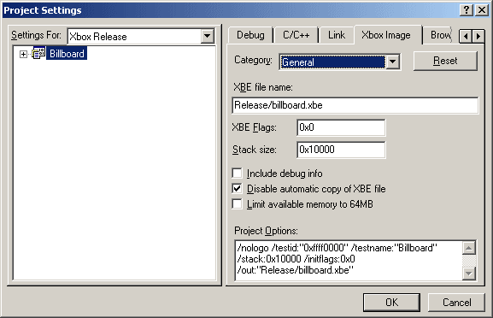
Check the option “Disable automatic copy of XBE file” – again…. You don’t have a Debug Xbox, so you can’t do this.
- Now go to the Post-build tab:
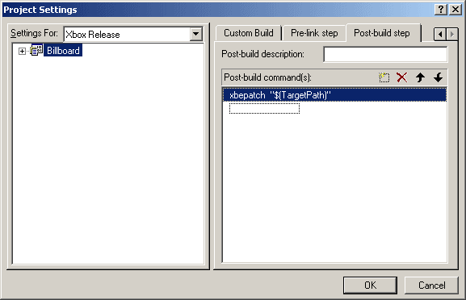
and change the xbcpy command with the following: xbepatch "$(TargetPath)" this will prepare the XBE file generated to run on the modified retail Xbox.
- Now the project is loaded and ready to work on and compile.

Running the results

Once compiled, simply use Evolution-X as an FTP server and copy the appropriate files into a work subdirectory on E: drive (just a suggestion here, but probably easier to keep clean this way) Many of the samples include “Media” directories that DO need to be copied over as well.

Once copied over, you can use a utility such as boXplorer to run your newly compiled application or simply use the Raw Command in FTP to “EXECUTE <filename.xbe>” (note: the FTP server does not need the path if you are currently sitting in that directory on the remote side)

Debugging

A few possibilities here –

First, at the http://www.xbox-scene.com site is a remote debugging aid that allows you to pass messages from your application over the network. This will give you a rudimentary trace message function.

Secondly, there is a possibility of turning your machine into a Debug Xbox… floating around is a copy of the Debug BIOS, as well as the “XDK Recovery Disc” which contains all the tools that allows a Debug Xbox to remotely debug and transfer files and such. I know of nobody who has tried to create a “Debug Xbox” so this may not be possible… and it’s said that using the Recovery Disc will effectively wipe out your Xbox. I suspect that the system may be incapable of running anything BUT XDK compiled applications. I can take no responsibility for anything that happens to your Xbox as a result of attempting to change it over. Do so at your own risk… however, for those brave enough (or with $200 to blow) to try, you may be able to create a dual BIOS system with a Modchip BIOS and the Debug BIOS – if you do so successfully, please give back to the community with a document detailing the process, as I did with this document.

Good luck.

